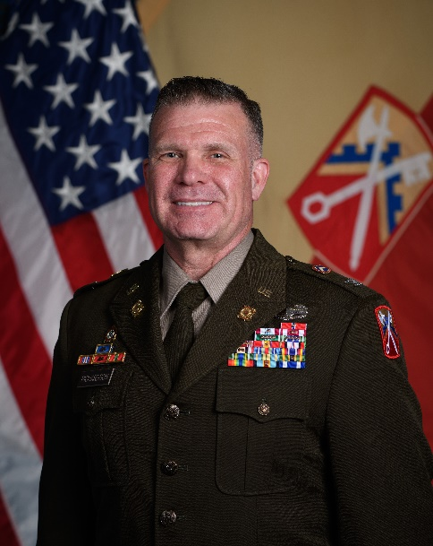
Colonel Christopher M. Richardson

Colonel Christopher M. Richardson serves as the Brigade Commander for the 16th Sustainment Brigade headquartered out of Smith Barracks (Baumholder), Germany.

He received his commission as an Ordnance Officer from Officer Candidate School in 2002. He is a graduate of the Ordnance Officer Basic and Advanced Courses, Advanced Navigation Course, and Command and General Staff College.

Before taking Command of the 16th Sustainment Brigade, he completed an Army War College Fellowship at the Massachusetts Institute of Technology’s (MIT) Center for Transportation and Logistics.

His command assignments include: Regimental Support Squadron, 2d Cavalry Regiment (Vilseck, Germany); Headquarters, Headquarters Battery, 377 Field Artillery Regiment, 17 Fires Brigade (JBLM, WA); 602d Brigade Support Company, 201st Battlefield Surveillance Brigade.

His non-command assignments include: Regimental Materiel Management Officer, Maintenance Platoon Leader, Shop Officer, and Support Operation Maintenance Officer in 3d Armor Cavalry Regiment and 4th Infantry Division; G5 Sustainment Planner and CJ35 Chief for 4th Infantry Division and COMKAF, NATO; Support Operations Officer for 1st Stryker Brigade Combat Team, 4th Infantry Division; and Brigade XO for 4th Divisional Sustainment Brigade, 4th Infantry Division. He also served as the J4, Chief of Sustainment for Joint Navigation Warfare Center, Kirtland, Air Force Base, Albuquerque, New Mexico. He most recently served as the Chief of Staff of the 21st Theater Sustainment Command headquartered in Kaiserslautern, Germany.

Colonel Richardson has deployed twice to Iraq and once to Afghanistan. He also deployed to Poland in 2023 in support of Assure and Deter operations.

Colonel Richardson holds a Supply Chain Analytics Certification from the Massachusetts Institute of Technology, a Master of Science in Business and Administration from Webster University, and a Master of Arts in Management and Leadership from Webster University. His awards and decorations include the Bronze Star Medal with OLC, the Defense Meritorious Service Medal with OLC, the Meritorious Service Medal with 4 OLCs, the Army Commendation Medal with 4 OLCs, the OIF and OEF Campaign Medals, and the Combat Action Badge.

Colonel Richardson married the former Rebecca Paty and has three children: Tyler, Taylor, and Hayley. He also has one grandson: Damien.

(Current as of June 2025)

